## Hospital and Community Care

### Summary

This section includes acute hospital data, delayed discharge bed days and A&E attendances.

**For the most recent time periods available, Moray had:**

* **8,475** emergency hospital admissions per 100,000 population, compared to 10,434 in Scotland.
* **62,077** unscheduled acute specialty bed days per 100,000 population, compared to 71,792 in Scotland.
* **24,789** A&E attendances per 100,000 population, compared to 25,791 in Scotland.
* **41,883** delayed discharge bed days per 100,000 population aged over 65, compared to 40,774 in Scotland.
* **1,811** emergency hospital admissions from falls per 100,000 population aged over 65, compared to 2,281 in Scotland.
* **85.7** emergency readmissions (28 day) per 1,000 discharges, compared to 106.5 in Scotland.
* **1,195** potentially preventable hospital admissions per 100,000 population, compared to 1,464 in Scotland.

##### Pagebreak

### Emergency Admissions

#### Figure 1: Emergency admissions by geographical area

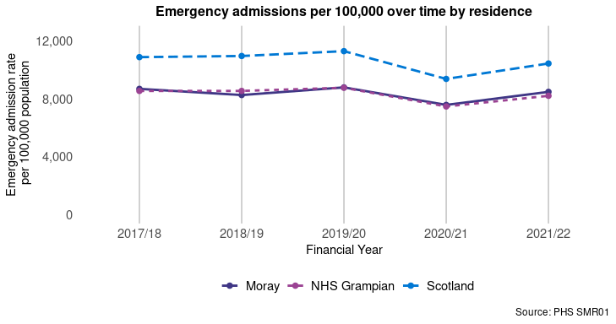

#### Figure 2: Emergency admissions by age group

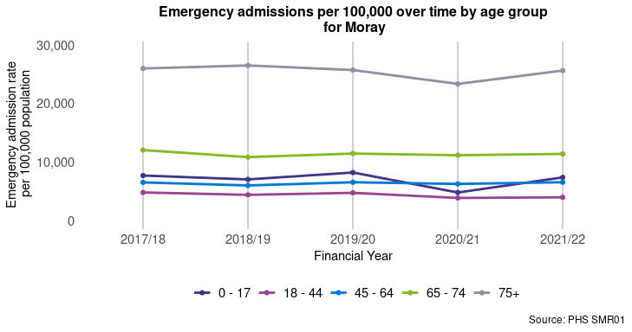

##### Page break

### Unscheduled Acute Bed Days

#### Figure 3: Unscheduled acute bed days by geographical area

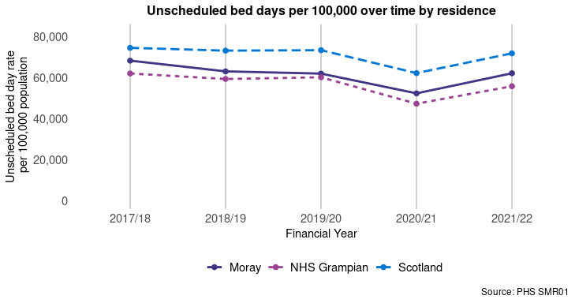

#### Figure 4: Unscheduled acute bed days by age group

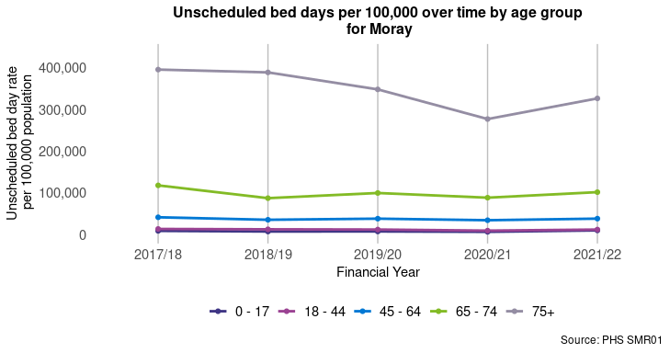

##### Page break

### A&E Attendances

#### Figure 5: A&E attendances by geographical area

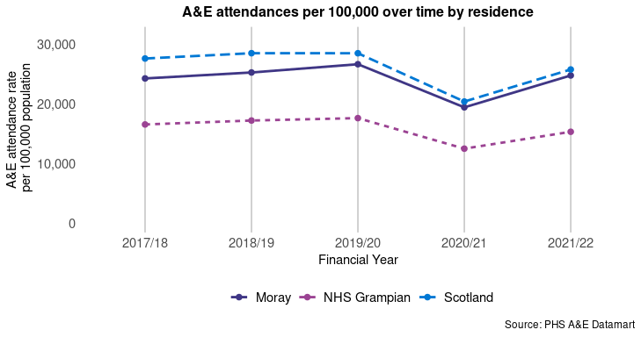

#### Figure 6: A&E attendances by age group

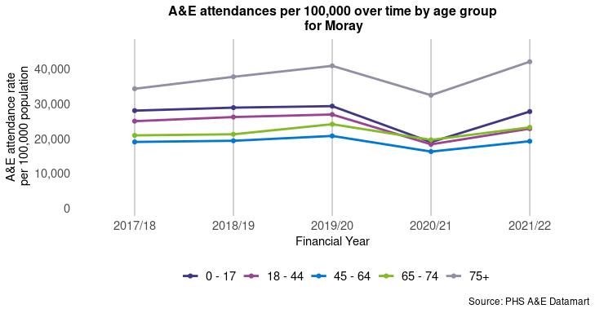

##### Page break

### Emergency Readmissions (28 days)

#### Figure 7: Emergency readmissions (28 days) by geographical area

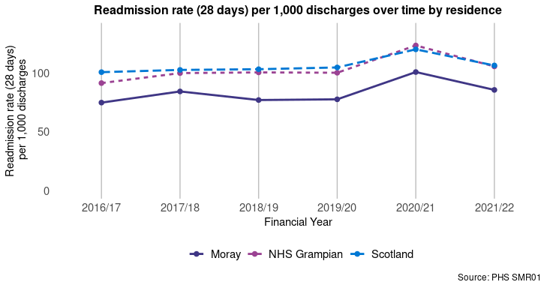

#### Figure 8: Emergency readmissions (28 days) by age group

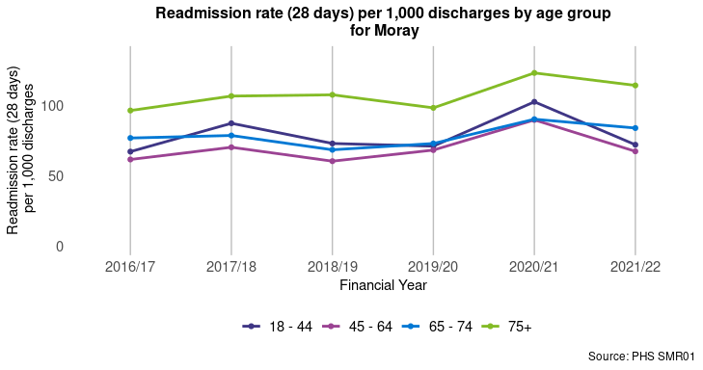

##### Page break

### Delayed Discharge Bed Days

#### Figure 9: Delayed discharge bed days in population aged 65+ by geographical area

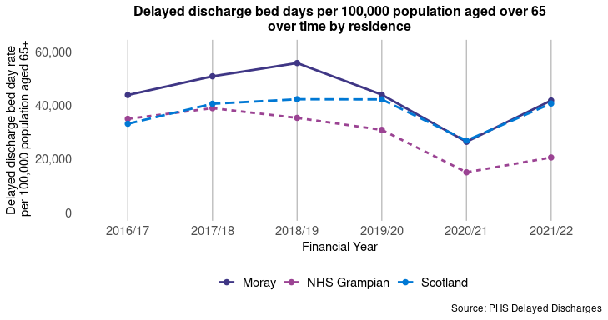

### Emergency admissions from a fall

#### Figure 10: Falls in population aged 65+ by geographical area

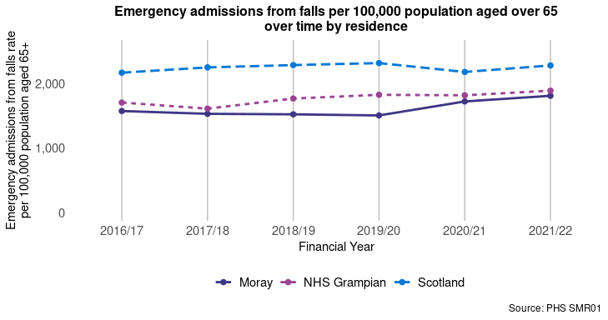

##### Page break

### Potentially Preventable Admissions (PPAs)

Information conditions included in PPAs is available in Appendix 3. In 2021/22, **52.1%** of PPAs in Moray were amongst those aged 65 and over, and **47.9%** were amongst those aged under 65.

#### Figure 11: PPAs by geographical area

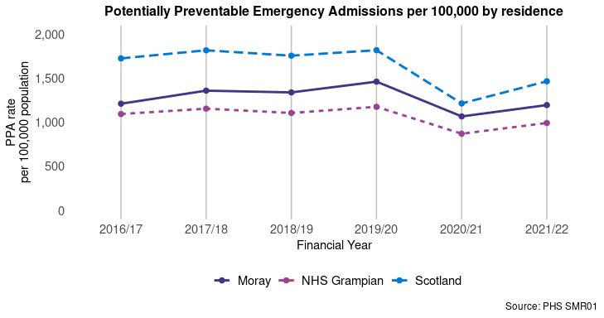

##### Page break

## Hospital Care (Mental Health Speciality)

### Summary

This section looks at mental health related unscheduled care indicators.

**For the most recent time periods available, Moray had:**

* **194.1** psychiatric patient hospitalisations per 100,000, compared to 242.8 in Scotland4.
* **9,848** unscheduled mental health specialty bed days per 100,000, compared to 18,672 in Scotland.

### Psychiatric patient hospitalisations

#### Figure 12: Psychiatric patient hospitalisations by geographical area

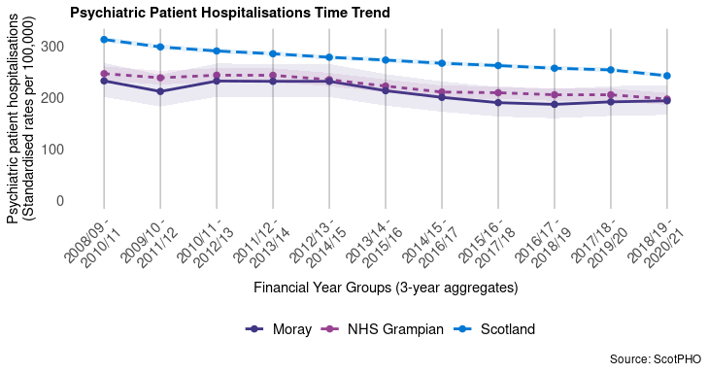

##### Page break

### Unscheduled Mental Health Specialty Bed Days

#### Figure 13: Unscheduled mental health specialty bed days by geographical area

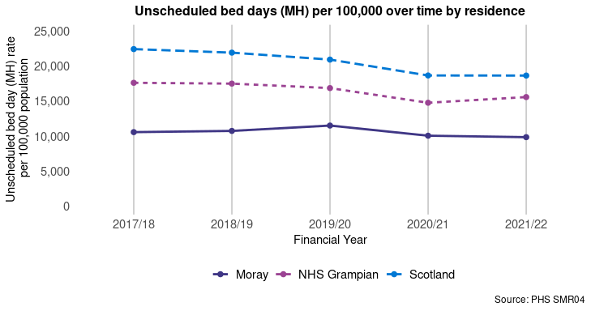

#### Figure 14: Unscheduled mental health specialty bed days by age group

